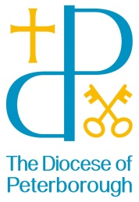
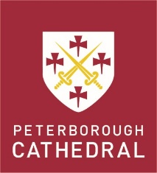
BACKGROUND INFORMATION

PETERBOROUGH CATHEDRAL
Peterborough is one of the new foundation cathedrals (together with Bristol, Chester, Gloucester and Oxford) created by Henry VIII as the monasteries were dissolved. There has been an Abbey on this site for over 1200 years, but the current building was begun in 1118 and this year we are celebrating our 900th anniversary. Among the many architectural glories of the Cathedral building are its iconic West Front, the painted wooden Medieval Nave ceiling and the splendid fan-vaulted New Building, created by the architect of King’s College Chapel in nearby Cambridge. The spacious Precincts still contain a number of monastic buildings and ruins. Inside, the Cathedral has been completely cleaned and restored following a major fire (2001), and is probably more complete and in better condition than at any time in its history. The Cathedral has a magnificent organ, one of the finest in the country, which has recently been re-pitched to concert pitch (A440) by Harrison and Harrison. The liturgical space is awe-inspiring and spectacular.

There is a lively Cathedral community including all age groups, and as well as regular worship led by the choir, it supports children’s and young people’s groups, education programmes, a theological society and a weekly lunchtime address. It contributes time and resources to a local project for the homeless, educational and other outreach initiatives, and provides hospitality to a variety of groups and gatherings. The Cathedral is principally the seat of the Bishop of Peterborough, and hosts many of the large diocesan services and events.

The Chapter of Peterborough Cathedral

The Chapter comprises four clergy and four lay canons. The clergy team includes the Dean, Chris Dalliston (2018), Vice Dean and Acting precentor, Tim Alban Jones (2015), a Canon Missioner, Sarah Brown (2018), and a part-time member, Ian Black (2012), who is also Vicar of St John’s Church in Peterborough city centre. Four lay members of Chapter represent specialisms from business, finance and property to HR, and also represent different aspects of the Cathedral community and diocese.

The staff

Chapter has been working over several years to establish a strong staff team within the Cathedral capable of delivering a high level of service in different areas. Staffing works in a collaborative way, with some projects shared between departments. Harmony and respect are important to this way of working. Specialist help, whether through resident staff or contracted-out arrangements, exists in areas such as publicity, media, education and visitors, personnel, health and safety, IT, management property and finance.

www.peterborough-cathedral.org.uk

THE DIOCESE OF PETERBOROUGH

The Diocese of Peterborough covers about 1,200 sq miles and includes the northern part of Peterborough, the whole of Northamptonshire and Rutland. There are two Archdeaconries: The Archdeaconry of Northampton covers the boroughs of Northampton and Wellingborough and the districts of Daventry and South Northants. The Archdeaconry of Oakham covers Peterborough, Rutland, the boroughs of Corby and Kettering and the district of East Northants.

The diocese is medium-sized in population with a little under a million people, but the rural areas of Northants and Rutland include many small villages with fine, and usually modestly proportioned, medieval churches. There is one diocesan bishop – Donald Allister, Bishop of Peterborough (2010), and one suffragan bishop – John Holbrook, Bishop of Brixworth (2011). The two archdeacons are Gordon Steele, Archdeacon of Oakham (2012) and Richard Ormston, Archdeacon of Northampton (2014).

www.peterborough-diocese.org.uk

