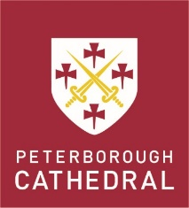
PETERBOROUGH CATHEDRAL
CANON PRECENTOR
PERSON SPECIFICATION

The successful applicant must be an Anglican priest, and will have the following:
- a well-developed theological understanding, with proven knowledge of – and skills and experience in – the fields of liturgy and church music
- liturgical creativity drawing on a secure understanding of traditional and contemporary liturgical practice
- a keen awareness of liturgical renewal, and a passionate concern for the place of worship in mission and evangelism
- a love and broad knowledge of music in general, and in particular a good knowledge and appreciation of the breadth of church music – both traditional and contemporary
- an understanding of, and commitment to, the distinctive character of ministry within a Cathedral setting, and to be committed with colleagues to establishing a prayerful and positive relationship
- a strategic mind, a proactive outlook and an entrepreneurial spirit
- the ability to be an able teacher and preacher
- the ability to sing confidently to a good standard
- the ability to show commitment to the theological and pastoral development of the wider Christian community
- excellent interpersonal skills and to be a team player – able to receive advice from others
- a proven track record in pastoral care
- generosity in outlook and openness in attitude
- the ability to enthuse and inspire others and bring out the best in people, especially those they supervise
- the ability to be well organised, a good planner and administrator – with the necessary IT skills – and an eye for detail
- a sound knowledge of safeguarding issues, and be prepared to undertake appropriate safeguarding training.

